Boost your child’s immune system

* **Get plenty of rest each night (8 hours sleep).**
* **Encourage healthy foods**
* **DAILY exercise out in the fresh air whenever possible**
* **Avoid exposing your child to second-hand smoking.**

# STUDENT HEALTH HISTORY and SERIOUS MEDICAL CONDITIONS

Let the school nurse know if your student has a:

* Significant health history
* Special medical concerns (e.g. life threating allergies, asthma, seizures diabetes)
* Needs medications while at school (Must have a written doctor’s order)
* Has had a communicable disease during the school year (e.g. measles, mumps, whooping cough)

# C:\Users\mmcku\AppData\Local\Microsoft\Windows\INetCache\IE\UXEMMBMX\remigho-syringe[1].png

# IMMUNIZATIONS Requirements

**All** students must meet state immunization requirements in order to attend school.

**Why?**

To reduce and eliminate vaccine-preventable diseases among school children, adolescents and adults.

**How can we reduce and eliminate vaccine-preventable diseases?**

• By making sure your child is up to date on all immunizations before your child begins in September and throughout the school year.

• If your child is coming from another state or country, the immunization records must be reviewed by the school nurse before the student is allowed to attend classes.

• Contact School nurse with any questions: 215-400-3320

https://www.philasd.org/studenthealth/#reqi

2024 **A Note from Your School Nurse…**

January 2024 ***Dedicated to keeping your children healthy***

### ACETAMINOPHEN, IBUPROFEN

Tylenol (Acetaminophen) and Motrin (Ibuprofen) may be given to the student with a **written** permission form (S865) completed and signed by the parent/guardian only. This form must be completed every year.

Nurses do not carry any over the counter medications in the office.

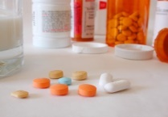 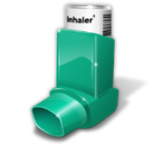

**Joseph H. Brown**

**3600 Stanwood Street**

**215-400-3320**

**•••**

https://jhbrown.philasd.org/

**MEDICATION AT SCHOOL - FORMS AVAILABLE AT SCHOOL OFFICE OR THROUGH SCHOOL NURSE**

If your child must receive medication in order to be in school, you will need to bring a “Medication Administration Record” (MED 1) form (<https://www.philasd.org/studenthealth/wp-content/uploads/sites/854/2018/08/Med-1.pdf> ), completed by your doctor or provider.

For your child’s safety: Student’s are never allowed to have any medications on their person or in their schoolbag at any time unless approved by the parent, principal, and school nurse.



Healthy Living

Teach your child to keep their hair and bodies clean:

1. Take daily baths or showers
2. Shampoo hair regularly
3. Use deodorant as needed
4. Brush teeth twice a day
5. Wash their hands often



#### New Year’s resolution ideas for kids (5 to 12 years old)

* I will drink water and healthy beverages like milk with meals. Soda and fruit drinks only for special times.
* I will wear my seat belt every time I get in a car.
* I will try to find a physical activity (like playing tag, jumping rope, or dancing) or a sport I like and do it at least three times a week!
* I will get 8-10 hours of sleep at night.

**Guidelines for Keeping Students Home from School**

* **Temperature over 99.9 degrees. (Temperature must be normal for 24 hours, without the use of medications, before the child returns to school).**
* **Nausea, vomiting, or diarrhea (must be clear from symptoms at least 24 hours, without the use of medications, before returning to school).**
* **Sore throat**
* **Earache**
* **Severe cold symptoms**
* **Coughing up green or yellow secretions**
* **Runny nose (if the mucus is yellow or green)**
* **Headache or stomach ache with other symptoms (e.g. cough or sore throat)**
* **A rash of unknown cause**
* **Pinkeye (If the child wakes up with a crusty or thick mucus like discharge or if whites of the eyes appear pink or red, and are painful and /or itchy. May return to school after treatment has started.**
* **Please do not send your child to school sick. When in doubt, keep them out.**

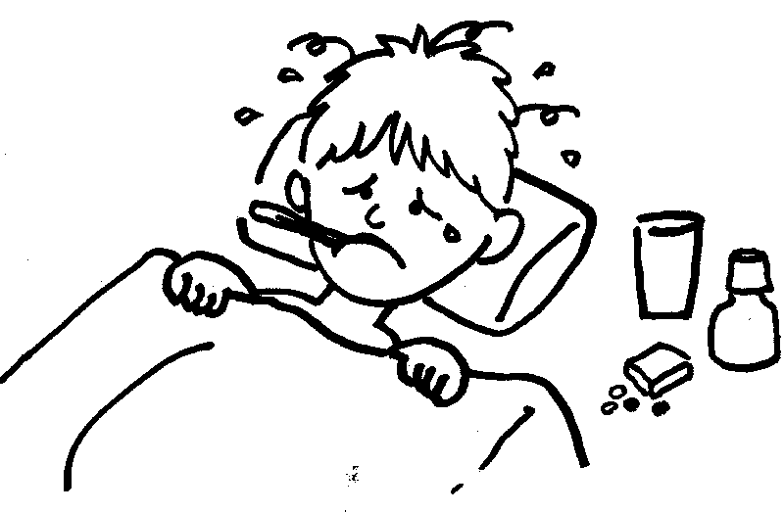

School Nurse

**Mrs. Maria Kulczytzky**

**Please feel free to call me with your questions.**

**215-400-3320**

**Mandated Exams**

**Physical Exam:**

**Please take your child for a Physical Exam and bring back completed physical if your child is in the first (1st) grade or sixth 6th  grade. Eighth graders will need the physical completed before they go to high school.**

**Dental Exam:**

**Please take your child for a Dental Exam and bring back completed form when your child is in the first (1st) grade, third (3rd) grade, and seventh (7th) grade.**

**The School nurse:**

* **The school nurse will provide physician ordered medications when prescribed between 11:00 AM and 1:00 PM only.**
* **The school nurse can only provide ice packs, bandages, soap, and water for cuts, abrasions, and lacerations.**
* **Remember -nurses cannot diagnose students and only treats them for immediate concerns that are occur during the school day.**